7.30

Implement first tick trader + newHiLoTrader

**Observations:**

Chinese like to clutter. When they swim, they like to follow each other, so you see situations where few swimmers follow each other and the rest of the lane empty.

Take advantage of this: you need to have better tech than average, which enables you to take advantage of their cluttering behavior, not go against it because it will tend to last for some time.

2 competing modes of thought:

1. Fight with them – get ahead and sell to them.
2. Be on the different direction and wait for reversal to happen

2 is much more difficult as craze can last a long time.

Identify high/low vol regimes is important.

Choose day’s delta based on first tick.

**731**

1. Market microstructure analysis

Follow open bid/offer, spread, size diff , output to file. Carefully study behavior around 9am and 9:30 am.

Xutrader – updateMktDepth – highly intractable.

1. Persistence of detailed FTSE data at the open (at least every second)
2. Open tick trade

Ytd bought, followed by pm rebound.

Today sold at the open, followed by AM weakness.

SEEMS that first tick has some predictive power on the earlier part and later part of the market.

Misc:

Technology wise, way ahead of retail

1. Auto placing orders, faster, keep increasing this advantage
2. MA trading needs to take into account percentile, this is first principle.

8/3

Weekly review:

Stocks: down 122k

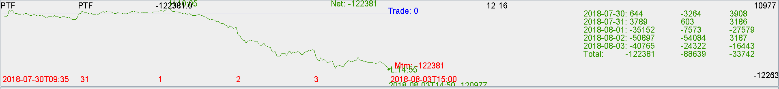

Futs:

Futs trading went well, up 100k.

FirstTickTrading was good with high success rate. Overnight selling at high percentile on Aug 1 was also good.

Keep doing first tick trading.

